The 1Latte application will be a replacement for data harvesting social media platforms such as Facebook and YouTube (Facebook and Google’s Pervasive Surveillance of Billions of People Is a Systemic Threat to Human Rights, 2019). The app focuses on providing users with an advertisement-free experience where they can socialize and discover trending topics. The application features a ranking system that will prioritize users and their content (Software Design Project, n.d.). This feature helps weed out bot accounts and spammers from manipulating the algorithm and feeding users false content (Software Design Project, n.d.). Open encryption will give users confidence about the privacy of direct messages. Encryption of messages protects 1Latte users from hackers by distorting the data while in transit (Webopedia: Online Tech Dictionary for IT Professionals, 2019). The ability to download and delete data gives users data privacy by putting them in control of how long data is retained and providing them easy access to data whenever necessary (Webopedia: Online Tech Dictionary for IT Professionals, 2019). 1Latte has a monthly subscription fee of $2.95. This price point allows 1Latte to be 100 percent advertiser-free from the start. The application was developed to function around the idea of data privacy, security, and equality (Software Design Project, n.d.). User content can be filtered, by using automated filters or by setting personal content filters (Software Design Project, n.d.).
The 1Latte platform focuses on the 18 to 45-year-old demographic. The platform is aimed at users who want more privacy in their lives. As technology advances the ability for individuals to remain anonymous grows rarer (Webopedia: Online Tech Dictionary for IT Professionals, 2019). Some may argue that anonymity on the web would allow for more bad actors to run rampant. The misuse of mass surveillance techniques can lead to widespread policing of the population by law enforcement and the government (Webopedia: Online Tech Dictionary for IT Professionals, 2019). 1Latte provides its users with peace of mind when it comes to data protection. An IT healthcare worker from Toronto, Canada named Pam is the perfect example of a future 1Latte user. Pam has a background in cybersecurity which has enhanced her understanding of what data privacy means. Pam views 1Latte as the final piece of her new data privacy-minded life. The application development on principles such as data control and privacy provides Pam and other customers with the comfort that their data will be safe from hackers and other bad actors.
The use of 1Latte within an organization would give employees the ability to safely transfer sensitive information to others. The messaging function of 1Latte allows employees, clients, and bosses to send and receive pertinent information. The information being encrypted means that personal and private information will be protected from hackers while it is being transmitted (Webopedia: Online Tech Dictionary for IT Professionals, 2019).
The front end and back end of the 1Latte application are still being programmed (Webopedia: Online Tech Dictionary for IT Professionals, 2019). The 1Latte social media platform will be released in the second quarter of 2025. The software development team has prioritized the completion and inclusion of all promised features at launch. Once the team has finished front and back-end work we plan on moving on to bug-testing and preparing the servers for launch.

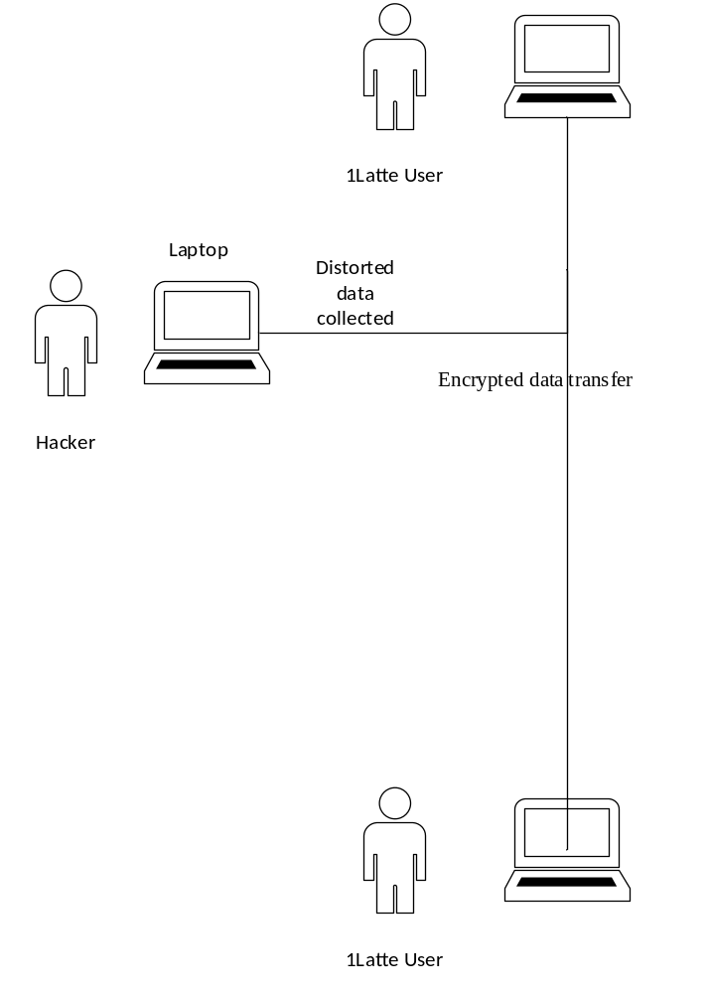

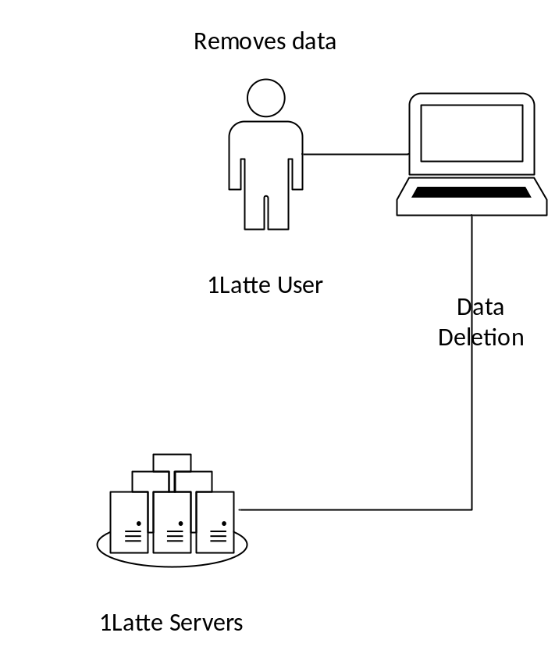

Resources: Software Design Project. (n.d.). Login.microsoftonline.com. Retrieved April 24, 2024, from https://learn.snhu.edu/content/enforced/1550935-IT-226-H4656-OL-TRAD-UG.24EW4/course_documents/Software%20Design%20Documents.pdf?_&d2lSessionVal=H5VxfYUqjVIQlMdZl4iMByYBy&ou=1332310&ou=1550935
Webopedia: Online Tech Dictionary for IT Professionals. (2019). Webopedia.com. https://www.webopedia.com/
Facebook and Google’s pervasive surveillance of billions of people is a systemic threat to human rights. (2019, November 21). Amnesty International. https://www.amnesty.org/en/latest/news/2019/11/google-facebook-surveillance-privacy-2/

